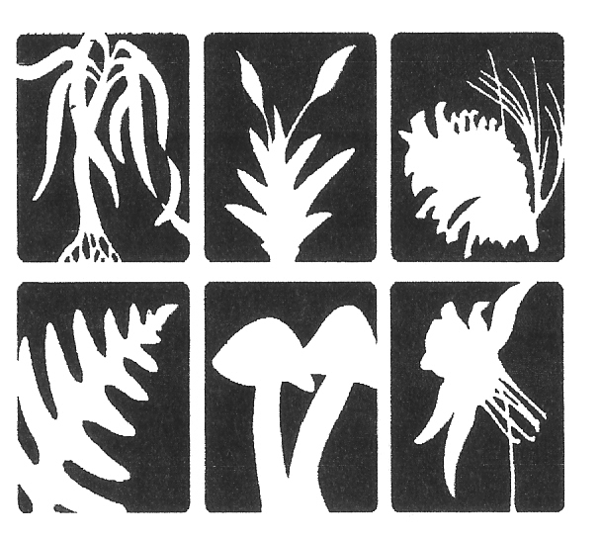  Botanical Society of America | Invitation to the 2019 Joint Field Meeting of the:  Botanical Society of America, Northeastern Section  Torrey Botanical Society & Philadelphia Botanical Club

August 11-15, 2019 (Sunday to Thursday)

Prairies of Adams County, Ohio

Shawnee Lodge & Conference Center, West Portsmouth, OH

Each year the Botanical Society of America, the Torrey Botanical Society, and the Philadelphia Botanical Club sponsor a field meeting in an area of the northeastern United States. The 2019 meeting will explore Adams County, Ohio and will be housed at Shawnee Lodge & Conference Center.
Adams County is located in the beautiful rolling hills of Southern Ohio. It is bounded on the southern side by the Ohio River. Adams County is noted for its fertile farmland, forests, wildlife, prairies and limestone deposits.

Field Trips (site descriptions taken from official web pages about these sites)
ADAMS LAKE PRAIRIE STATE NATURE PRESERVE - This sparsely vegetated xeric, or dry, prairie is situated on a highly eroded slope of calcareous Estill Shale surrounded by a second-growth oak-hickory woodland. Red cedar, post oak and blackjack oak occur sporadically in the prairie opening.
Prairie grasses are sparse, but Adams Lake Prairie supports diverse prairie forbs including a stand of prairie dock. Some of the interesting plants found growing at this cedar barren prairie include spider milkweed, shooting-star, green milkweed, Carolina buckthorn, American aloe, slender blazing-star and large summer bluets. (http://naturepreserves.ohiodnr.gov/adamslakeprairie)
CHAPARRAL PRAIRIE STATE NATURE PRESERVE -This is an outstanding xeric limestone prairie with post and blackjack oak. It supports the most extensive population of rattlesnake-master in the state. Prairie dock and spiked blazing-star are also unusually abundant at this site.
Eleven state-listed species have been recorded at the preserve including spider milkweed, prairie false indigo, pink milkwort and American bluehearts. Little bluestem is the dominant prairie grass.
(http://naturepreserves.ohiodnr.gov/chaparralprairie)
KA-MA-MA PRAIRIE – The region provides canvas for classic prairie open grasslands, cedar-dominated glades, light-shaded dry bluffs, and young forests composed of oaks, hickories and scrub pines. The grasslands have an unusual number of classic short-grass prairie species such as Little Bluestem, Prairie Dock, Rattlesnake Master, and False Gromwell. The extremely rare Prairie Gentian was found here and is one of only two known locations in the entire state. (http://arcofappalachia.org/ka-ma-ma-prairie/)
CHALET NIVALE PRESERVE - The dolomite bedrock of Chalet Nivale creates a compelling karst-country landscape of springs, seeps, grottos, and sinkholes. These alkaline soils and bedrocks are renowned for producing a diverse assemblage of rare and endangered wildflowers, ferns and shrubs, including herbs with prairie-associations, such as Climbing Milkvine, Stiff Gentian and Tall Larkspur. Ancient White Cedar Trees, isolated hundreds of miles south of their normal range in the North Woods, cling to the bluffs of the cliffs. (http://arcofappalachia.org/chalet-nivale-preserve/)

E. LUCY BRAUN LYNX PRAIRIE PRESERVE - Designated a National Natural Landmark in 1967, Lynx Prairie was protected to save the best of the few remaining remnants of the once extensive prairies of this area. This preserve features a series of natural grassland openings that appear as islands in an otherwise forested area. These natural openings, called cedar barrens or glades, are prevalent throughout the preserve system. (https://www.nature.org/en-us/get-involved/how-to-help/places-we-protect/edge-of-appalachia-lynx-prairie-trail)

DAVIS MEMORIAL STATE NATURE PRESERVE- Geologic features include excellent Silurian dolomite cliffs. Both Greenfield dolomite and Peebles dolomite are exposed. Ohio black shale occurs on the tops of the knobs. An impressive fault, causing vertical displacement of 30 feet, exposes adjacent cliffs of Greenfield and Peebles dolomite.
The preserve's dolomite cliffs provide habitat for white cedar and sullivantia. American aloe, dwarf hawthorn, hairy wing-stem, side-oats gramma grass and purple coneflower are found in the prairie openings. Other significant species include tall larkspur, limestone Adder's-tongue fern, narrow-leaved bluecurls and Walter's violet. (http://naturepreserves.ohiodnr.gov/davismemorial)

Evening Speakers (talk titles to follow)
Sunday evening -Guy Denny
Monday evening – Allison Cusick
Tuesday evening – Martin McAllister
Wednesday evening - Rick Gardner

Facilities
We have access to a room that will likely be available for plant ID after hours.

Lodging
Housing will be at Shawnee Lodge & Conference Center, 4404B State Route 125
West Portsmouth, Ohio 45663. All lodge rooms are air-conditioned/heated and have satellite television, AM/FM alarm clock radios, telephones, iron and ironing boards, refrigerators, bathtubs, and a private balcony.

Dining
Breakfasts and dinners will be served at Shawnee Lodge & Conference Center. Lunch is box-style and will be picked up at breakfast. Shawnee Lodge requires that all food and beverages be purchased through the lodge.

2019 Joint Field Meeting Registration - Maximum 50 Participants - Deadline June 1, 2019

This meeting is open to anyone interested. It is not restricted to members or the sponsoring organizations.

Name(s): ______________________________________________________________________

Address: ______________________________________________________________________

Cell Phone _______________________email_________________________________________

Do you need vegetarian meals? _____ Other dietary restrictions? _________________________

There is a $15 additional fee/person for attendees who are not members of the Botanical Society of America. This $15 fee will be donated to BSA on your behalf. Alternatively, we suggest everyone join this fine organization. Memberships start at $25, provide many benefits, and include the $15 fee.

Speakers, field trips, meals, and lodging (double occupancy)….…$575.00/person
Speakers, field trips, meals, but NO lodging …………………...…$325.00/person
Speakers, field trips, but NO meals or lodging……………………$175.00/person

Amount (see above) __________ X _____ persons Subtotal __________

Donation for non-members of Botanical Society of America:

$15.00 …………………………. X _____ persons Subtotal ___________
Payment enclosed Total ___________

Make your check for full payment, payable to the Botanical Society of America, and send with this registration form to: Bonnie L. Isaac, Carnegie Museum of Natural History, Section of Botany, 4400 Forbes Avenue, Pittsburgh, PA 15213

I can be a driver for car-pooling _______ Excluding myself, I can take ______ other people.

Person with whom you wish to share a room __________________________________________

You may assign me to any room, but I prefer a male _____ prefer a female ____ don’t care ______

Emergency Contact _____________________________________ Number _________________

I am a member of the Botanical Society of America _______, Torrey Botanical Society _______,

Philadelphia Botanical Club _______, Other _________________________________________

In making this application, participants affirm that they are in general good health, are physically able to keep up with the group in the ordinary course of field activities, accept as their personal risk the hazards inherent in any outdoor activity, and will not hold the Botanical Society of America, or other sponsoring organizations, or the trip leaders responsible for the same.
I give my permission for medical treatment to be administered in such case as deemed necessary by a trained medical professional. I accept and assume all risks associated with recreation activities, and I hereby release Trip Organizers and Leaders of all liability from injuries that might occur. I understand that I am responsible for providing my own insurance for any injuries that occur.

Signature ________________________________________________ Date _________________

